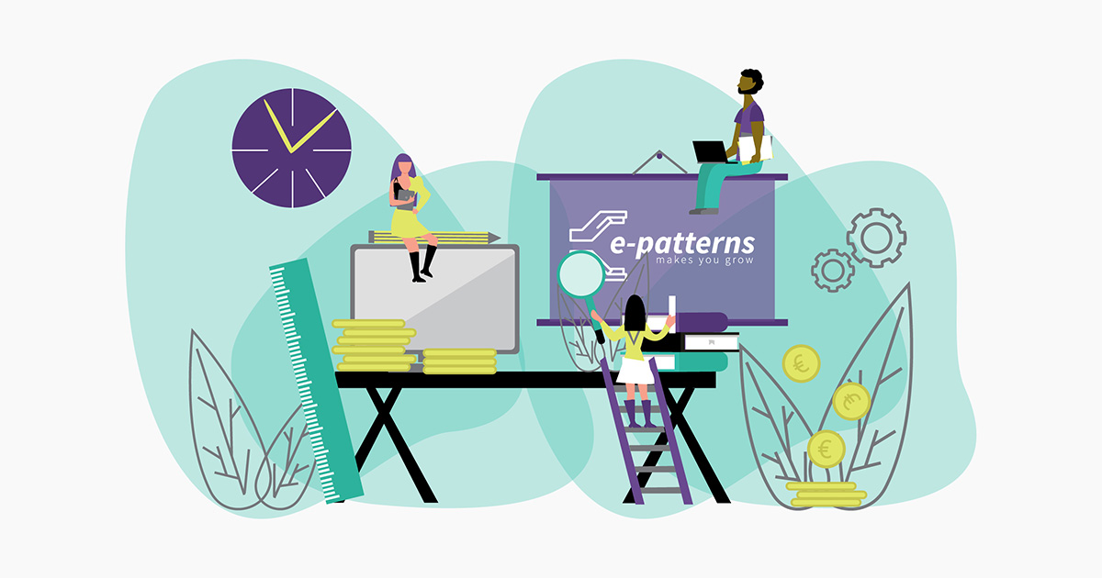

Evaluation Plan Template

Evaluation Plan Template

Who will be responsible to collect data | Why do I need to evaluate? | What do I need to find out? | What will I measure? | How will I measure it? | Who will I collect data from? | When will I collect data? | What will I do with the data?
 | - Identify evaluation purpose  - Identify evaluation audience | - Identify evaluation questions | - Select outcomes and outputs for measurement  - Identify indicators | - Select data collection methods  - Ensure data is good quality | - Determine sample | - Develop timeline | - Data analysis  - Evaluation write-up  - Dissemination

